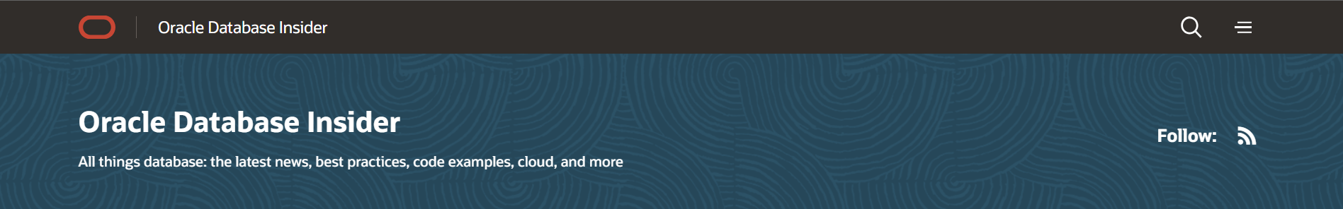
Product News
Announcing Oracle Database 23ai : General Availability
May 2, 2026 16 minute read
Dominic Giles
Vice President Product Management
General Availability
We are pleased to announce the general availability of Oracle Database 23ai. Over the last four years, Oracle Database Development has worked hard to deliver the next long-term support release of the Oracle Database, with a focus on AI and developer productivity. Given the focus on AI in this release of the database, we decided to change the database’s name from Oracle Database 23c to Oracle Database 23ai. This reflects the focus of this release as well as the climate in which it is being released.
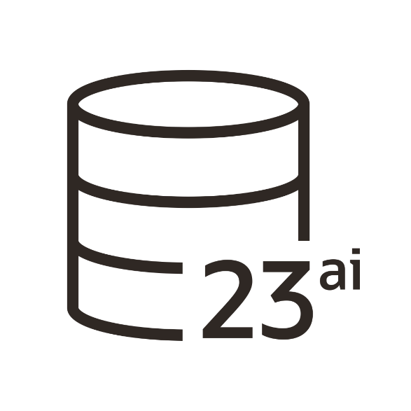
Game-Changing Innovations
Oracle Database 23ai has focused on three key areas.
- AI for Data
- Dev for Data
- Mission Critical for Data
In this Blog, we’ll describe some of the critical features of this release that highlight our work on these important focus areas and provide details when you see them on your platform of choice.

AI for Data
Our goal with AI for Data is two-fold:
- To enable app developers to add AI functionality into their data-driven applications more easily
- To incorporate GenAI capabilities into our products so that all users of Oracle Database, from data analysts to app developers and DBAs, can be more productive.
This is achieved by employing AI to streamline Oracle’s data management processes, offering AI algorithms for uncovering new insights from your data, facilitating natural language interactions for database queries, and empowering users to store AI-generated vectors for swift and efficient object similarity searches. Let’s delve into these features further.
Augmenting a new generation of AI models
People are feeling the impact of AI Large Language Models (LLM), exemplified by offerings such as ChatGPT, Google Gemini, Cohere, and LLaMA. Whilst LLMs are having a profound impact on the way we perform everyday tasks, one of the challenges that these engines face is that they are restricted to answering questions in the specific time window of their creation. They also lack context and details of the data held within your organization. To make these and other LLMs useful, we need to augment their existing understanding with data relevant to the questions you ask about the data held within your database.
In Oracle Database 23ai, we are introducing AI Vector Search, a powerful new technology that enables you to leverage a new generation of AI models to generate and store vectors. These vectors, sometimes referred to as embeddings, are multi-dimensional representations of documents, images, videos, sound, etc. By encoding these objects as vectors, you gain the ability to look for similarities between them using mathematical calculations. The real power of Oracle Database23ai’s solution is that you can combine these similarity searches with searches on your business data using simple SQL. Anyone with a basic understanding of SQL can create a powerful statement combining similarity and other search criteria. These types of queries provide LLMs with additional context, augmenting their knowledge and making their responses more accurate and relevant to your customers’ or organizations’ questions. To enable this functionality, we’ve added a new data type, new vector indexes, and extensions to the SQL language to make it incredibly simple to query vectors alongside your existing business data by leveraging Oracle Database 23ai’s advanced analytical capabilities.
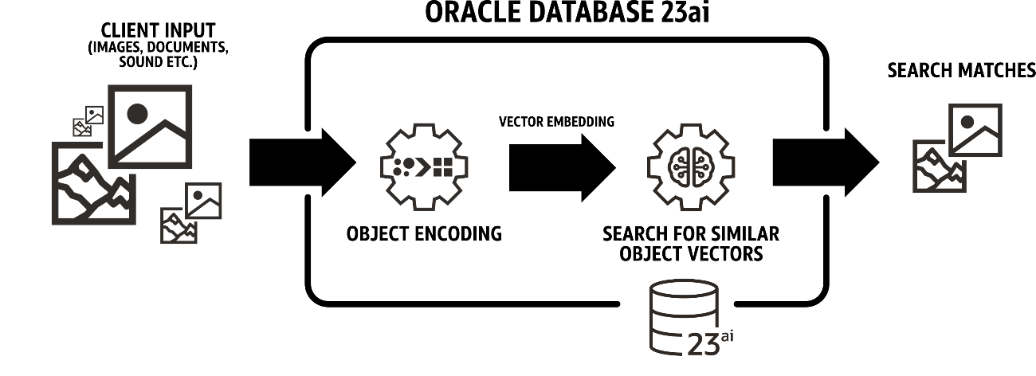
Secure encoding of data
To enable the considerable benefits that LLMs offer, we first need to enrich our understanding of our datasets and the objects within them. The models to encode these objects are potentially large and complex pieces of code. As a result, it has become common practice to offload this processing to third-party services. This can require you to share potentially sensitive information with third parties with the inherent risks that entails.
To ensure the secure encoding of objects, Oracle Database 23ai allows you to load your own trusted AI models directly into the database through its support of the ONNX standard. This enables Oracle Database 23ai to encode objects as they are inserted into the database. This enables the secure near real-time inferencing of objects and ensures that data does not need to be extracted from the database and handed off to a third-party service.
Asking questions naturally
While SQL is an incredibly powerful language, it can be a little challenging to get started with. To enable a broader range of users to ask the most complex questions of the Oracle Database, we are integrating with LLMs such as Cohere and Llama to allow you to ask questions using natural language. So you can simply ask a question like “Show me the last 4 quarters’ sales of products that are popular with the younger generation”. Oracle Database 23ai will share the table’s metadata to answer the question with the LLM along with the user’s question. The LLM understands the meaning of “younger generation” and converts it into a data range as a filter in the SQL query, which it returns to the database. We, of course, aren’t limiting Oracle Database 23ai to just allowing you to query the information within the database. You’ll also have the ability to ask questions on all aspects of the Oracle Database.
Finding new insights in data
Since the release of Oracle Database 9iR2 over 20 years ago, the database has featured built-in Machine learning (ML) algorithms, enabling you to quickly look for patterns and trends in data held within its tables and predict customer behaviors. These ML algorithms give you the ability to use sophisticated ML algorithms without the need for complex ETL operations to extract the data and write back results. These models could then be used to classify, cluster, and predict as your data is inserted or loaded into the Oracle Database, providing tangible business benefits like customer recommendations and fraud detection. Since that release, we’ve improved and added new ML algorithms and capabilities to the Oracle Database, creating one of the industry’s most sophisticated and capable data mining platforms.
Feedback from early testers
AI Vector Search generated a great deal of interest even before the launch, and many customers and partners were keen to try out and provide feedback on the latest capabilities like AI Vector Search. Here’s a sample of the feedback we received.
“We are happy to see AI Vector Search added to Oracle Database. We appreciate that we can run AI Vector Search in the same Oracle Database as our other workloads, which allows us to provide a reliable and secure solution.”
Shinichiro Otsuka, NRI Certified IT Architect, Nomura Research Institute, Ltd.
“AI Vector Search changes the way we think of the business by bringing AI to your data: for instance we can use natural language to query our documentation to find answers to questions customers are asking. This makes the process of serving customers much faster and the quality of the service improves as well. Being able to use the power of Generative AI with our own data makes a huge difference.”
Heli Helskyaho, CEO, Miracle Finland Oy
“We have been consulting on various business transformation projects using advanced digital technology. Oracle Database 23ai AI Vector Search is very simple to implement by adding a vector column to the current relational database system. I am thrilled that the vector data is within a single record with existing data so that similarity reordering can be done with a single SQL statement. This makes it easy to combine large language models and company data to create and operate enterprise-level retrieval augmented generation systems.”
Shigeru Urushibara, Chairman, UL Systems Inc.
“With the decreasing domestic workforce in Japan, XCAT‘s customers want to adopt labor-saving measures. Oracle Database 23ai’s AI Vector Search allows customers to use SQL for vector retrieval, making it an excellent tool for engineers with little or no AI knowledge to handle vector data. In addition, the ability to manage AI data at no additional cost is a major attraction for many Oracle Database customers.”
Mitsunori Yamane, President, Cross Cat Co., Ltd.

Dev for Data
Oracle Database 23ai focus was to make the experience of developing applications simpler by removing the complexity associated with your database interaction. Removing complexity from the application development process means you get more opportunities to focus on the intricacies of creating elegant applications that meet your customer’s requirements rather than getting bogged down in technical details. Moreover, reducing complexity can lead to faster development cycles, this is crucial in today’s fast-paced digital landscape, where market demands can shift rapidly.
JSON or Relational, a difficult choice?
Oracle 23ai introduces a number of key technologies to reduce the complexity for developers. Perhaps the most innovative and important of them is the introduction of JSON Relational Duality. This technology allows you to leverage the power of relational and the simplicity of JSON development approaches all within a single app. JSON provides an elegant data modeling approach where all of the relevant data needed to answer a query is contained in a single object without the need to perform complex joins across tables. The relational approach provides a flexible, storage-efficient, consistent data model that is easy to query with languages such as SQL. Historically the problems come when you are forced to choose which database modelling approach to take at the start of your application lifecycle. Decisions made at this stage may have implications much later on as the business requirements change. The beauty of JSON Relational Duality is that you can benefit from both approaches without the need to use complex and unwieldy Object Relational Mapping frameworks (ORMs).
By creating simple JSON Duality views on top of relational tables you can build applications that use documents to query and update the underlying data sets. Data duplication, a fundamental issue in document modeling, is avoided, and even the complexities of database-level concurrency control are hidden from you as Oracle Database 23ai manages document-level serializability on your behalf. You can continue to use simple HTTP PUT, POST, and GET operations or use language-specific API such as Oracle’s SODA API or even MongoDB API directly against the Oracle database. With JSON Duality Views the old phrase of “You can’t have your cake and eat it” no longer holds true.
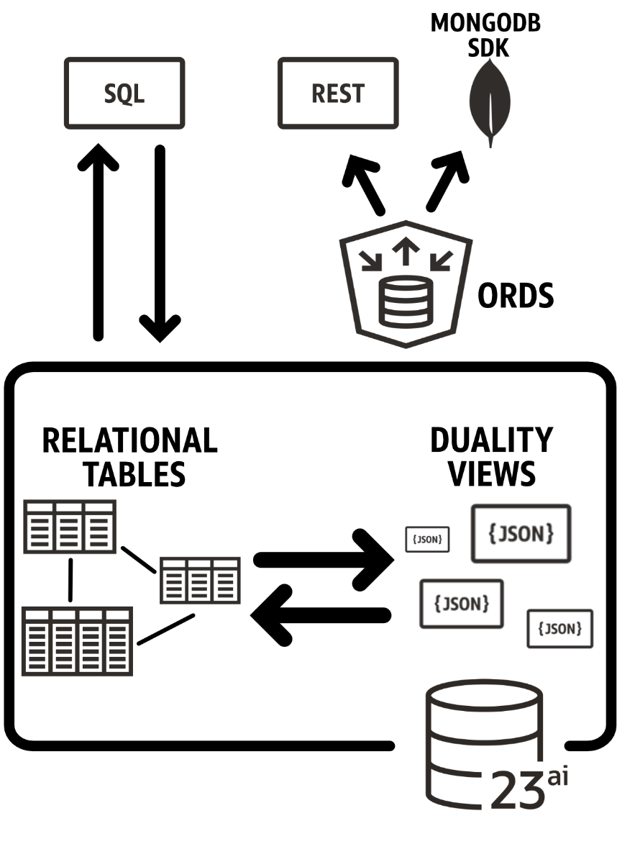
SQL just got a little easier
SQL remains one of the most popular development languages in use with application developers today. Its versatility when asking the simplest or most complex questions of your business data has made it the cornerstone of data management, a position it is likely to hold for the foreseeable future. That is not to say there are areas where it could be improved. In Oracle Database 23ai we listened to common enhanced requests and looked at what could be made simpler or offer more compelling ways to interact with the database. Examples of just a few of the SQL improvements we’ve made include the addition of two new datatypes “Boolean” and “Vector”, we added “Data Use Case Domains” to allow you to enrich the meaning of datatypes used in table definitions, the removal of the need for “from dual” in simple SQL statements to improve readability, making it easier to aggregate over the “interval” datatype, the introduction of table value constructors to make it easy to specify multiple rows in insert select or merge statements. These are just a few of the many improvements we’ve made to SQL. Check out this blog for further details.
As with AI Vector Search, we also appreciate receiving a lot of useful feedback from customers and partners who participated in the Oracle Database 23ai Beta program. Here’s a sample of the comments we received –
“JSON Relational Duality Views are a game changer for application development by finally solving the problem of object-relational mapping. And, we at last have ACID-compliant transactions in a multi-tier or web architecture.”
Peter de Vaal, Principal Consultant, Transfer Solutions
“JSON Relational Duality gives you the best of both worlds: Relational experts can work on the same data as Document database experts without having to learn a new skill. App developers have the flexibility they need, and database management is simpler. Oracle has taken a massive leap beyond other databases.”
Patrick Barel, Sr. Oracle Consultant, Qualogy
“Oracle Database 23ai with JSON Relational Duality Views and Oracle APEX have allowed us to create full-featured, standards-compliant applications for working with JSON healthcare data.”
Rade Pobulic, Technical Director, VDEL Informationstechnik & Consulting GmbH
Property Graphs modeling complex relationships
Graph databases provide a fresh perspective on modeling intricate relationships found in real-world scenarios. Yet, until recently, developers grappled with proprietary languages and having to ship data to databases tailored for managing these relationships. This hindered the widespread acceptance of this groundbreaking technology. Fortunately, the industry has taken a collaborative approach to bring graphs to the masses, culminating in the establishment of standards. These standards empower developers with the versatility and familiarity of SQL, fostering a more accessible landscape. Oracle Database 23ai stands as the pioneering commercial database to embrace this newfound standard. With these advancements, we anticipate a significant surge in the integration of Graph databases within enterprise ecosystems.
As with JSON Duality Views, you can express your intent on how you would like to use your data held within existing relational tables or your JSON collections through the user of property graph views. With a simple view, you can enrich the data to model the potentially complex relationships that your data holds. A new SQL extension makes it much simpler to write powerful queries to find a deeper understanding of information that would have been hard to describe using standard SQL. We’ve also added a new set of sophisticated graph algorithms (shortest path, classification, connects, etc. ), which will be released shortly after GA.

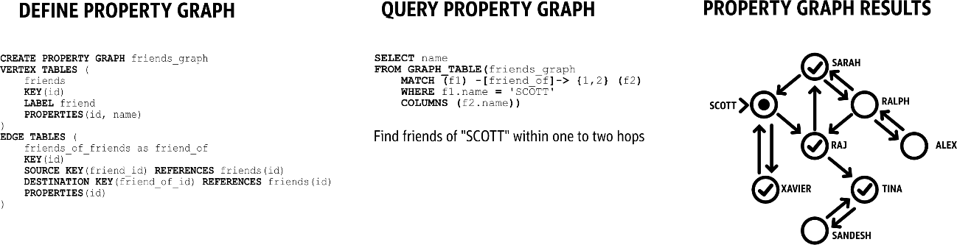The property graph Property Graph is available in all editions of Oracle Database 23ai.
Mission Critical for Data
Oracle Database is renowned for powering some of the world’s most vital applications. Over the years, it has established itself as a stalwart guardian of businesses’ most precious asset: data. Unrivalled in its breadth of features, Oracle Database excels in safeguarding critical systems against unforeseen downtime. A prime example is Oracle Real Applications Clusters (RAC), a cutting-edge technology that enables all-active, shared disk databases, ideal for the most mission-critical scenarios. Oracle Active DataGuard and Oracle GoldenGate offer unparalleled flexibility in crafting both homogenous and heterogeneous architectures for data replication.
Shard better, faster, simpler
For use cases where businesses are looking to distribute their data over larger distances, either for regulatory reasons where the data of users must be stored in the country the customer resides in or to reduce the latency of access associated with globally distributed applications: We introduced support for database sharding in Oracle Database 12c. Sharding distributes a dataset across a number of Oracle databases but is managed as a single logical data set. This sharded architecture allowed the database to be scaled up or down by adding and removing shards and allowing Oracle to automatically rebalance the dataset. Oracle is able to do this online and with little impact on the business as the concept of sharding is baked directly into the database.
In Oracle Database 23ai our Globally Distributed Database technology introduces support for Raft replication. This is a consensus-based protocol that facilitates the automatic configuration of replication across all shards. With raft, replication holds copies called replication units across all of the shards. In the advent of a shard failure or reconfiguration, Oracle Database 23ai automatically rebalances the data. The new Raft protocol also enables sub-second failover to ensure continued business continuity.
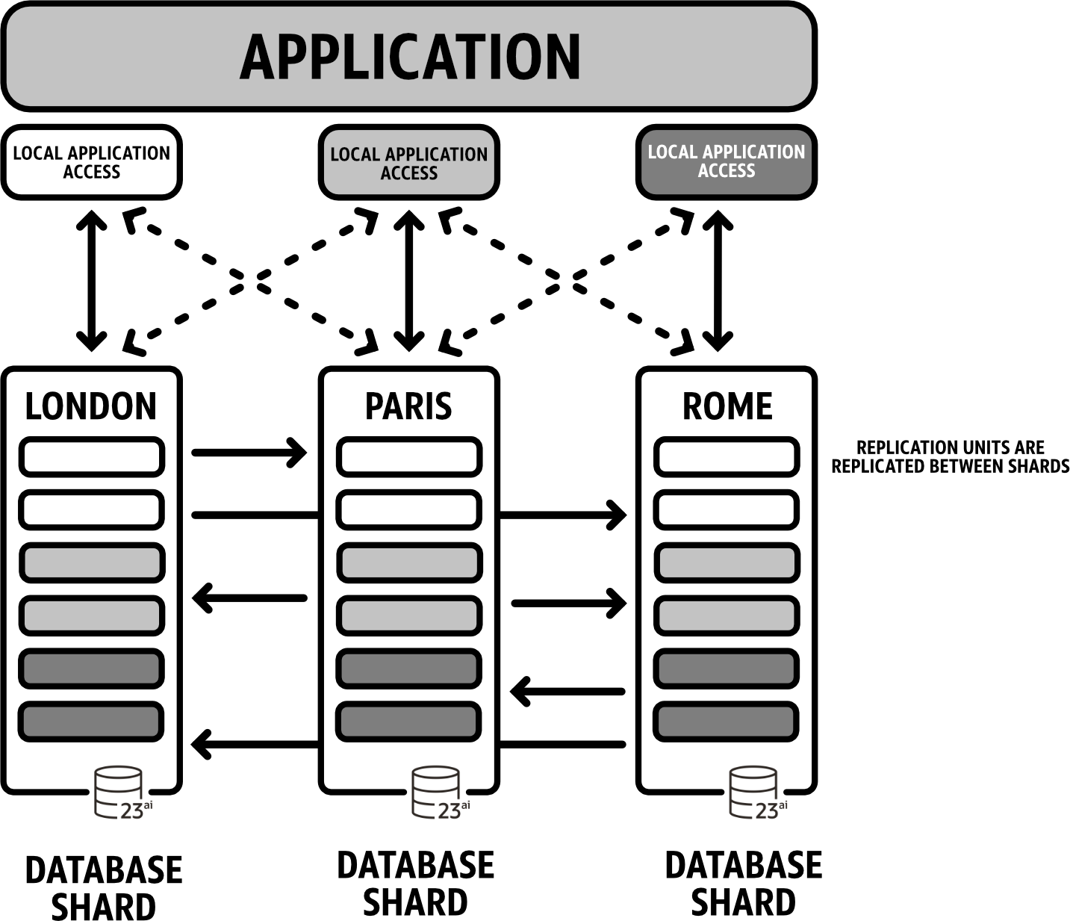
Oracle 23ai brings a number of improvements across the board for our high availability products, such as the new “Local Rolling Database Maintenance” to simplify the impact of rolling patches in a cluster by standing up another instance on the same node that is receiving the patch. We are also introducing support for a new Data Guard Per Pluggable Database (PDB) allowing Pluggable Database level disaster protection between two Container databases (CDB) with each CDB running an active workload. We’ve also improved the integration and management of PDBs within Oracle Clusterware. For more details on these HA features and many more, please take a look at Markus’s blog where he goes into more detail on the improvements we’ve made in Oracle Database 23ai.
Caching data made simple
Caching data in the application tier can offer considerable benefits. It is often used to make applications more responsive and reduce the load on the database, as queries are offloaded to the cache typically located closer to the code. However, to achieve these benefits, developers face a number of challenges; one of the biggest is ensuring that the cache is consistent with the data held within the backend database or risk serving stale and potentially incorrect data. Developers are often forced to create complex code to manage these scenarios and often have to resort to design patterns such as “time to live” where data is periodically flushed from the cache and reloaded. These and many other challenges often mean the cache becomes difficult and expensive to maintain and, in some instances, a bigger problem than the one it was designed to solve.
In Oracle Database 23c we are looking to solve the problems of caches built against the Oracle Database with a new feature called “True Cache”. True Cache is a diskless Oracle Instance running in front of the primary database. The True Cache instances leverage Active Data Guard technology to ensure it is automatically updated as data changes in the primary database instance. One of the most important features of this new caching technology is its simple configuration and minimal code changes that are needed to leverage the benefits it offers.
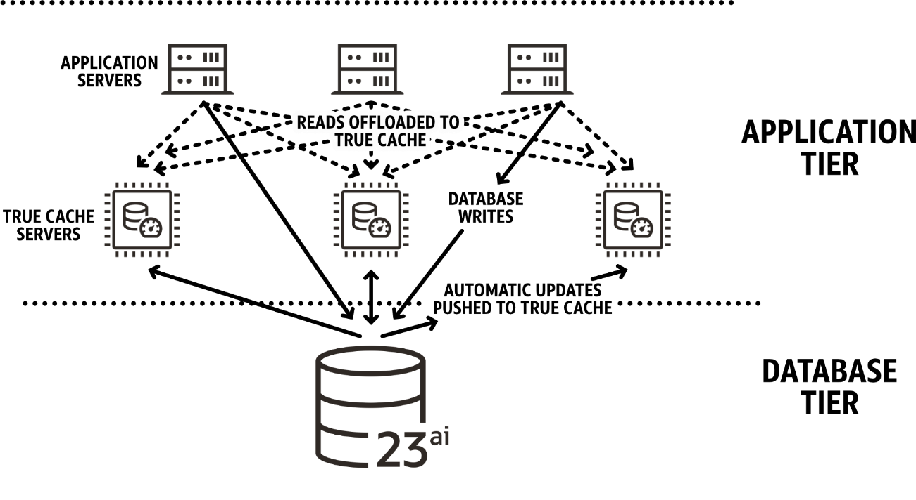

Making SQL execution safer
One of the challenges that organisations face is continued attempts by malicious actors to steal data or disrupt their day-to-day activities. In Oracle Database 23ai, to prevent the execution of unauthorised SQL, be they via SQL-Injection attacks or simply by unauthorised staff, we are introducing SQL Firewall. SQL Firewall allows you to train the Database on what SQL is permitted to be executed. The “allow list” of SQL can then be used to either log unauthorised SQL or block its execution. Additional criteria can be added to allow exceptions for IP ranges or authorised calling programs. The power of SQL Firewall is that it is part of the Oracle Database, and as a result, it imposes very little overhead on the execution of SQL. Setting up and training SQL Firewall is incredibly simple being able to be done from a GUI or via a few simple calls to stored procedures.
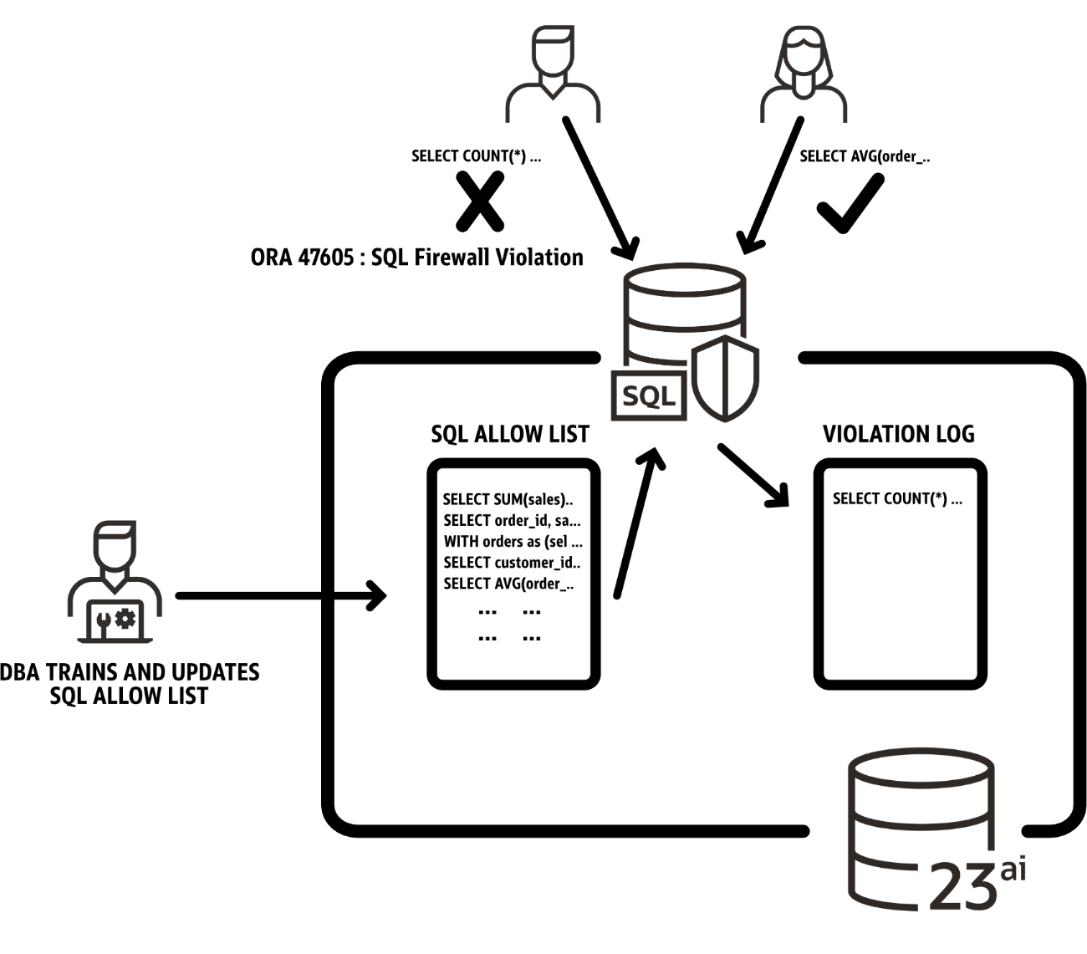
Over 300+ new features
In my previous Blog I discussed the cloud release of Oracle Database 23ai and described some of the 300+ new features. Some other notable features include
- Java Script Stored Procedures
- Priority Transactions
- Data Use Case Domains
- Schema privileges
- Annotations
- Boolean datatype
- Developer Role
- Read-Only-Per-PDB Standby
- JSON Schema
- Real-Time SQL Plan Management
- Performance Improvements
- Lock Free Reservations
- Improved Microservice Support
- XML and JSON Search Index Enhancements
- And many many more
For a detailed breakdown of these please also review the New Features Guide documentation
Platform Rollout
Oracle Database 23ai is now available on Oracle Exadata Cloud@Customer, OCI Exadata Database Service and OCI Base Database Service. It is also available in the Oracle Database@Azure, Oracle Database@Google Cloud, and Oracle Database@AWS. For developers, Oracle Database 23ai is now available in Always Free Autonomous Database as well for download in the Autonomous Database 23ai Container Image and Oracle Database 23ai Free. For on-premises deployments, Oracle Database 23ai is available on Oracle Exadata and Oracle Database Appliance (ODA). We are also pleased to announce that Oracle GoldenGate 23ai and GoldenGate 23ai Free as also available for download. For further details please check the Oracle Support note Doc ID 742060.1
The general availability of Oracle Database 23ai marks a new phase in this important release. Thousands of developers have contributed to its design, development and testing resulting in what we believe is the very best enterprise database in the market.

https://blogs.oracle.com/database/oracle-23ai-now-generally-available

